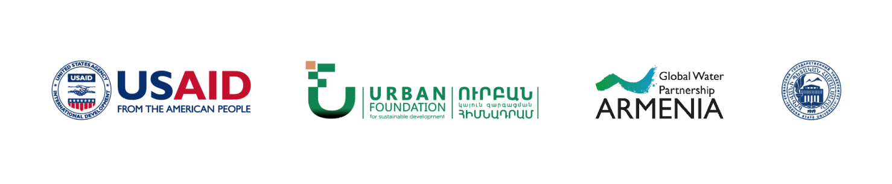

“Participatory and Efficient Use of Water Resources” (PURE-Water) Project

Improvement of the Regulatory Framework for the Raised Efficiency of Water Users Associations and Water Users Associations Unions

Yerevan, April 2019

Cooperation agreement: AID-111-A-17-00005

Project name: “Participatory and Efficient Use of Water Resources” (PURE-Water) Project
Financed by: United States Agency for International Development (USAID)
Implemented by: “Urban” Foundation for Sustainable Development, “Country Water Partnership” NGO, YSU Environmental Law Research Centre

This paper was made possible by the support of the American people through the United States Agency for International Development (USAID). The contents and opinions expressed herein are the sole responsibility of the authors and do not necessarily reflect the views of USAID or the United States Government.

Contents
Introduction 4
Background Information of the Current Status 4
Irrigation System Management 4
Dispute Resolution 9
Control and Oversight 10
Irrigation System Related Administrative Offences and Administrative Proceeding 10
Financial Stability of WUAs 12
Project Activities 13
Irrigation System Management 13
Participatory Management of WUAs 15
Dispute Resolution Mechanisms 17
Publicity and oversight 18
Irrigation System Related Administrative Offences and Administrative Proceeding 21
Financial Stability of WUAs 21
Project Coordination 22

Introduction

The project for improvement of the regulatory framework for the raised efficiency of Water Users Associations and Water Users Associations Unions (hereinafter referred to as the “Project”) is a large-scale partnership between public authorities, water users and the civil society. The aim of the project is to analyse the regulatory framework of irrigation water use and implement amendments into the RoA Law on “Water Users Associations and Water Users Associations Unions” and other related legal instruments, and managements mechanisms that would ensure WUAs’ self-reliance, accountability, transparency and participation in governance, would provide public administration system with good quality and coordinated information on the activities of WUAs and water users, would establish effective mechanisms for protecting the own interests of water users, and would ensure that civil society has access to sufficient information and tools for control.
Project actions are conditionally divided into two groups: 1) actions to prepare the regulatory framework required for reforms, and 2) actions to implement those improvements.
Project development was based on the following materials: “Household Survey on Water Use in Ararat Valley” conduced by “Urban” Foundation for Sustainable Development in the scope of “Participatory and Efficient Use of Water Resources” (PURE-Water) Project (funded by USAID), and regulatory analysis conducted by “Urban” Foundation for Sustainable Development and YSU Environmental Law Research Centre in the scope of the project for “Assessment of Water Resource Management Policy and Regulatory Framework and Development of Improvement Measures”.

Background Information of the Current Status

Irrigation System Management
Irrigation system is a part of the Armenian water system comprising of irrigation and drainage pipelines, canals, aqueducts, pipe canals, galleries, chutes, tunnels, overfalls, overchutes, pipelines, hydraulic structures, artesian and fountain pits, pumping stations, reservoirs, ponds and service roads with relevant land acquisition zones, buildings and structures, power lines and other infrastructures, including water and ecosystem protection zones.
Irrigation water supply management can be conducted either by a Water Systems Management Body (public administration) and/or private management.
Based on the RoA Government Decree No 1653-N, dated 17 October 2002, the State Water Committee of the RoA Government was recognized as a Water Management Authority (in recent years the Water Committee has been operating under different ministries, and now it is envisaged to include it in the structure of the RoA Ministry of Territorial Administration and Infrastructures).
The latter is a state authority operating in the sector of management of the RoA Ministry of Energy Infrastructures and Natural Resources. It is responsible for development and implementation of the state policy on the management and use of state-owned water and non-competitive water supply systems.
Private management of irrigation water supply can also be conducted through participatory management by Water Users Associations and/or Water Users Associations Unions in the manner prescribed by law.
Based on Article 4 of the RoA Law “On Water Users Associations and Water Users Associations Unions”, both the association and the union are non-profit legal entities operating and maintaining irrigation systems guided by public interest. Both the association and the union are established to supply irrigation water to water users.
The Association supplies irrigation water to water users located in its service area, while the Union ensures supply to its service area associations based on the basin management plans.
Currently, there are 15 WUAs operating in the Republic of Armenia responsible for distribution of irrigation water among water users. Since the adoption of the law, no WUA has been created in Armenia.
On the other hand, Articles 32 and 32.1 of the RoA Law “On Water Users Associations and Water Users Associations Unions” define the subjects with coordination authority of WUA activities and their powers. The analysis of the above-mentioned articles shows that there is a clear differentiation in the scope of the powers of those two entities thus delegating state intervention authority for design and implementation of policies of WUA activities to a more collegial and balanced body in the form of Regulatory Board, while assigning the Water Systems Management Body with the authorities related mainly to technical operation of water bodies or hydraulic structures.
Moreover, considering that board membership is conducted on a non-paid basis, it was intended to set up an executive body for the Regulatory Board to support the activities of the Board and implement oversight functions over WUAs on its behalf. At the same time, the RoA Law “On Water Users Associations and Water Users Associations Unions” should have defined a narrower scope of authority than the full coordination of WUA activities, to the Water Systems Management Body (Water Committee of the Ministry of Energy Infrastructures and Natural Resources, at the time of writing this document). The purpose of such system concept is to counterweight and counterbalance various interests of the water sector.
However, this balance provided by the Legislator has been violated by the first statutory acts defining the structure and regulations of the system. Based on RoA Government Decree No 1768-N, dated 17 October 2002, Clause 3, powers of the Executive Body of Regulatory Board of the activities of Water Users Associations and Water Users Associations Unions have been delegated to the “Water Sector Development and Improvement PIU” state agency under the State Water Management Committee of the RoA Government. However, Article 32 of the RoA Law “On Water Users Associations and Water Users Associations Unions” states that “the Regulatory Board conducts its activities through the Executive Body”. Thus, implementation of functions of the two entities, through clear differentiation of the powers defined by law, has been delegated to the same entity, i.e. the Water Committee since 2002 (in fact, from the very beginning).
Moreover, before 2016, based on the Government decree on changing the composition the Regulatory Board, the latter was managed at ministerial level, and the interested departments were represented by their managers or the Deputy Minister. However, following the changes of 2016, Chairman of the State Water Committee became the Chairman of the Board. Only after the amendments of 15 November 2018, RoA Deputy Minister of Energy Infrastructures and Natural Resources was reassigned to the position of the Chairman of the Board, bearing no significant impact on counterbalancing of interests. Thus, since 2016, the Board has been chaired by the Chairman of the Water Committee, the Office of the Board has been functioning under the Water Committee, and the Water Committee has been acting as Water Systems Management Body thus disrupting the logic of the RoA Law “On Water Users Associations and Water Users Associations Unions”, which defines clear differentiation between the powers of the Regulatory Board and the Water Systems Management Body. Consequently, the Water Committee has obtained full and unbalanced coordination levers over WUA activities, leading to imposition of political decisions, such as agglomeration of WUAs, appointment of WUA directors through instructions of representatives of the Executive Authorities, and other unacceptable interventions.
On the other hand, because of artificial and forced “agglomeration” of WUAs, the yet poorly rooted mechanisms of participatory governance are becoming purely formal. International best practice assumes creation of WUAs covering an area of 5000-6000 hectares at maximum; initially, this approach was the case for Armenia, as well. However, before 2017, the Government has implemented regular reorganization and agglomeration activities in order to increase the effectiveness of WUAs, which contradicts both the principles of self-governance and the efficiency of participatory governance. To justify the aforementioned, let’s have a look some data collected through a sociological survey conducted within May and June by “Urban” Foundation of Sustainable Development in the scope of “Participatory and Efficient Use of Water Resources” (PURE-Water) Project. The survey represents a confidence level of 95% and a confidence interval of 5%.

Figure 1. Efficiency of various bodies/organizations in solution of water issues in the community (assessment scale 1-5 (%))
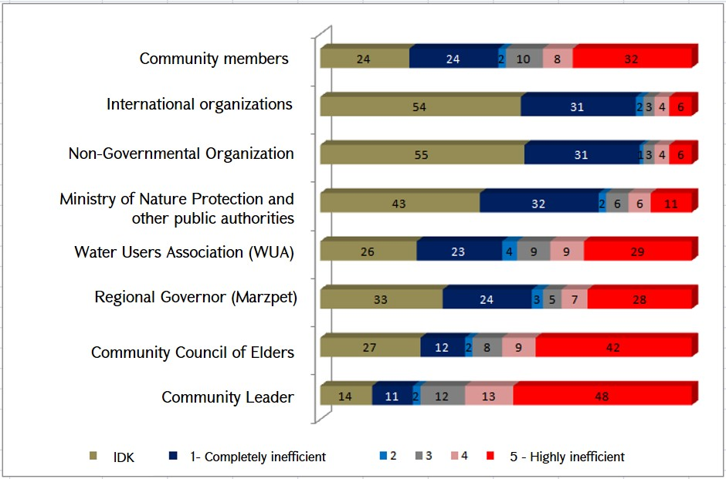
The overwhelming majority of community members - 61%, believe that it is their community leader that is able to solve issues related to irrigation and drinking water in their community. Then comes the Council of Elders (51%), and the community members themselves (40%). Meanwhile, 38% of community members tend to trust this function to WUAs, and 35% to the regional governor (marzpet). Community members do not believe that the RoA Ministry of Nature Protection or other government agencies, NGOs or international organizations are able to solve water-related issues in their community.
According to the survey results, most of the residents of the Ararat Valley (96% and more) are not actively involved in water resource management processes, nor have they received relevant information or participated in water resource management trainings.
The overwhelming majority of residents (69%) noted that they would participate in discussions on drinking or irrigation water in their community upon availability of such discussions. It should be mentioned that men (due to cultural norms) show more active involvement in this issue: it is 80% of men that have responded positively to this question, compared to only 61% of women respondents. Middle-aged and elder people have expressed more willingness to participate in such discussions than the youth.
In terms of participatory management, access to information on WUAs is another issue. Currently, none of the existing WUAs has an official website. Their charters, irrigation schemes, budgets, performance records, staff structure and staffing lists are not published on any online platform. Only executive summary of information on irrigation period indicators of WUAs of the year 2018 and information presented in WUA-related decisions of the Government are available. In addition, other outcomes of the sociological survey, related to water users’ awareness, are given below.
50% of community members obtain information on water-related activities in their community mostly from peer community members, 35% - from community water inspector (water fee collector/ water distributor), 15% - from TV, 3% - from the community leader, 1% - from the Internet, 1% - from community posters, 0.3% - from the radio, 6% - from other sources, and 12% mentioned that they obtain no information at all.
Figure 2. Information sources on water-related activities in the community
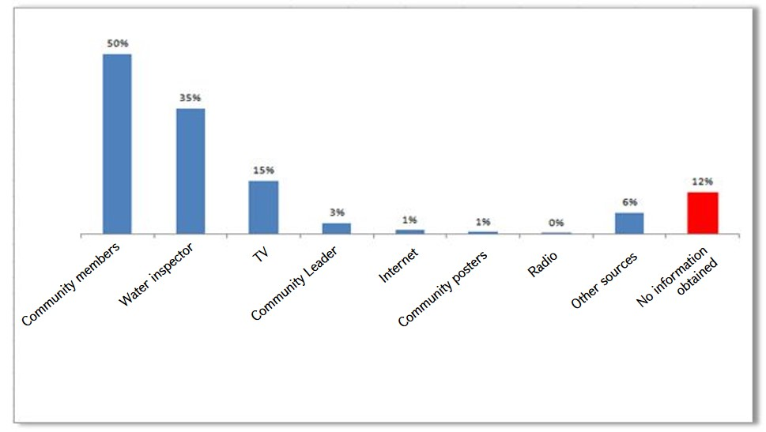
According to the same survey, 70% of households are not aware of water users’ rights and responsibilities, or have no water supply agreement with the WUA.
Thus, it can be noted that water users are mainly not involved in the irrigation system management process. In addition, taking into account the non-paid basis of participation into the self-governance system, informed and active citizens, a few in number, are not tending to take responsibility for the operation of the system due to the lack of additional legitimate or unlawful interest. On the other hand, the RoA Law “On Water Users Associations and Water Users Associations Unions” does not provide sufficient guarantees for the representation of WUAs, enabling organization of meetings with non-representative groups (or no meetings at all) and making decisions that way.
Consequently, WUA governing bodies have not been selected by water users and do not enjoy their support; on the other hand, all WUA coordination functions are centralized within one authority - the Water Committee. In these conditions, WUA managers do not perceive themselves as representatives of an autonomous body, but rather act as agents of the Water Committee. This situation can be expressed in one statement - “No rights, no responsibilities”.

Dispute Resolution
Obviously, both in the past and in the present, there have always been numerous disputes in water use sector seeking appropriate solutions. Moreover, from the perspective of the important function water resources have for each state and individual, such issues should be addressed through less time-consuming mechanisms, if possible.
In particular, based on Article 12 on the organizational structure of the association, the Association holds a meeting to elect a Dispute Resolution Commission consisting of at least three members. Within its exclusive competence, the General Assembly of the Association is entitled to elect the members of its Dispute Resolution Commission and to terminate their powers ahead of time, reimburse the expenses incurred by the Dispute Resolution Commission, and approve the Charter of the Dispute Resolution Commission. Members of the Association having any unpaid irrigation water fee, a membership fee or other debt payable to the latter, cannot be elected as a member of the Dispute Resolution Commission. Actually, the competences of the members of the Dispute Resolution Commission and the terms of their activities are defined by the Charter of the Association, while the procedure of the Commission’s activity is defined by the Charter of the Dispute Resolution Commission. The Dispute Resolution Commission functions through sessions, convened as necessary, upon the request of the member(s) of the Association or on the initiative of the Association’s Administrative Council and/or the Management.
Actually, the Charter of WUAs clearly stipulates a relevant dispute resolution mechanism, however, it should be noted that the actual inactive performance of dispute resolution commissions and the absence of minutes of meetings of dispute resolution commissions indicate that disputes are not actually considered. It should be noted that, despite of available detailed legal regulations, the de facto existence of the dispute resolution commissions prescribed by law and the Charter of WUAs, the latter, practically, do not resolve any dispute.

Control and Oversight
The regulatory framework envisages oversight mechanisms for the control of WUAs, including public oversight and control by such entities, as WUA Oversight Board, Water Systems Management Body, Regulatory Board and other public authorities within the scope of their powers prescribed by law. Regarding public oversight, Para. (c), Article 5 of the RoA Law “On Water Users Associations and Water Users Associations Unions” defines the principle of right of a WUA and its members to have free access to information on the activities of WUAs and WUA Unions. However, no additional regulation or WUA obligation is defined in terms of publishing detailed information on their activities. WUAs do not provide civil society organizations with any documents required to draft measurable assessments on their activities, and they do not have official websites. In such conditions, the possibility of de jure public oversight is de facto impossible.
To evaluate the activities of WUA supervisory committees, it is sufficient to note that despite the situation existing within WUAs for years and major corruption crimes disclosed since 2018, supervisory committees have never conducted any valuable research or detected any violations.
Regarding the oversight conducted by the Water Systems Management Body and the Regulatory Board, the legal analysis outlined above shows that those two functions are actually implemented by the Water Committee. The review of the Committee’s website shows no public information available on the outcome of those oversight functions, meaning either lack of execution of relevant powers, or more likely, lack of proper public accountability, bearing significant corruption risks and highlighting availability of additional intervention levers over WUA activities. At the same time, it should be mentioned, that this situation is not a result of a certain political will or the lack of it, but rather of the nature of legal arrangements of the system. Consequently, new quality management should be based not only on the appointment of new and honest personnel, but also design of concepts derived from new and honest practices.
Irrigation System Related Administrative Offences and Administrative Proceeding
The RoA “Code on Administrative Offences” defines administrative offenses related to water systems (including drinking water) and the form and extent of liability thereof. They include:
- Disposal of trash and consumption wastes into water systems, including irrigation canals and sanitary protection zones.
- Violation of ownership rights of water systems or their components, acquisition and/or transfer of the right to use water systems through breach of law.
- Improper use of natural water objects by breaching the established water use rates; violation of rules for initial calculation of water quantity taken from and discharged into water objects; and violation of rules for determination of the quality of water discharged into water objects.
- Use of water through violation of water supply and water use rules (including voluntary use), irrational use of water, self-initiation of hydraulic engineering works.
- Damage to water systems and facilities, including water meters and measuring and regulating equipment of water supply systems, inlets of multi-apartment buildings, apartments and dwelling houses; failure to install seals, change (falsify) or intentionally remove the seals of those equipment.
- Breach of rules for the use of water systems and facilities, including water meters and measuring and regulating equipment of water supply systems, inlets of multi-apartment buildings, apartments and dwelling houses.
- Violation of access to maintenance and inaccessible zones of water systems.
- Breach of safety norms of emergency hydraulic structures or reduction of indicators thereof.
- Breach of rules (conditions) for using water resources for leisure and sports.
- Breach of maintenance guidelines for main pipelines.
- Failure to comply with the requirements of the compulsory norms for the shared ownership of a multi-apartment building.
Article 239 of the same Code defines that the cases of the abovementioned offenses are examined by the Water Systems Management Authority. Entities entitled to investigate cases of administrative offenses and impose administrative fines on behalf of the Water Systems Management Authority include: Chief State Inspector for the Use and Protection of Water Systems, Deputy Chief State Inspector for the Use and Protection of Water Systems, Senior State Inspectors for the Use and Protection of Water Systems, Inspectors for the Use and Protection of Water Systems.
RoA Government Decree No 1278-N of 17 September 2003, Para. 2, Clause (b), “On amendments and addendums to the RoA Government Decree of 5 September 2002 “On Approving the Charter and Structure of the State Water Committee”” defines that the Chairman of the Water Committee shall, at the same time, hold the position of the Chief State Inspector for the Use and Protection of Water Systems of the Republic of Armenia. However, this article has been annulled by the RoA Government Decree No 705-N of 8 June 2018, and the new Charter of the Committee was approved on 11 June 2918, by Order No 62-L of the RoA Minister of Energy Infrastructures and Natural Resources. The Charter does not contain an equivalent provision of the previous act.
At the same time, distribution of powers of former inspectorates, in the process of creating inspection bodies, has not been fully implemented towards newly established inspection units. The authority for the enforcement of norms for the use and protection of water resources has been delegated to the Environmental Protection and Underground Resources Inspection Body, while the powers relating to the enforcement of norms for the operation and protection of water systems has not been transferred to any competent authority.
Referring to liabilities defined for irrigation system related administrative offences, it should be noted that such administrative offenses are more difficult to identify and hard to prove, and the rates of fines are not sufficient to ensure proper behaviour, taking into account the large number of irrigation water users, extensive coverage of the system, lack of human resources required for supervisory and inspection functions. Even the administrative fine is much smaller than the unlawful profit expected from the offense.
On the other hand, very often, administrative offenses are committed through an illegal deal between WUA officials and water users or due to reflectance from the side of WUA officials. In addition, the RoA Law “On Water Users Associations and Water Users Associations Unions” does not specify the responsibility of water users and WUA employees to report any water sector related offences to the Authorized Body. There are no effective warning mechanisms, either.

Financial Stability of WUAs
Review of correlation between the expenses and the income of WUAs from the moment of their establishment shows that they have never crossed the self-coverage threshold and are not even sufficiently close to it. Lack of complete fee collection has numerous varied reasons, including poor administration, inefficient management, low solvency of water users due to the low profitability of agricultural sector, “passive boycott” of water users against poor management, low water charges compared with high electricity tariffs, system depreciation, losses, water theft, etc. However, even with a hundred per cent fee collection, the income has never covered and will not cover the accrued expenses. In this situation, governments have never considered revision of water fee by increasing it from 11 drams per cubic meter; the financial gap was sufficiently subsidized instead. Capital investments into the system and capacity building of WUAs could be viewed as an alternative to abrupt reduction of losses; however, such policy requires a large amount of financial resources, which the Government lacks at the moment. On the other hand, regular subsidies to WUAs do not allow for their autonomy in the system, strengthening internal capacities and considering about progress towards development. Therefore, development and implementation of a new policy for financial sustainability of WUAs should constitute a separate chapter of sector improvements.

Project Activities

Irrigation System Management
Considering the aforementioned description of the irrigation system management, it is obvious that on the one hand, it is impossible to underestimate the importance of state regulation in the process of managing this system, while on the other hand, given the large number of stakeholders and the diversity of interests available in the water sector, the regulation should be as balanced and comprehensive as possible. From this perspective, it is necessary that the Regulatory Board, envisaged by Article 32 of the RoA Law “On Water Users Associations and Water Users Associations Unions”, constitutes a high platform for development and implementation of policies, and consideration and settlement of crosscutting interests. This may become possible with concurrent availability of the following two essential prerequisites:
- All interested agencies shall be represented in the regulatory board at the level of policymakers.
- The board shall be supported by professional and honest expertise, independent from all agencies.
Within 2005-2018, the official status of Board members has been gradually lowered.
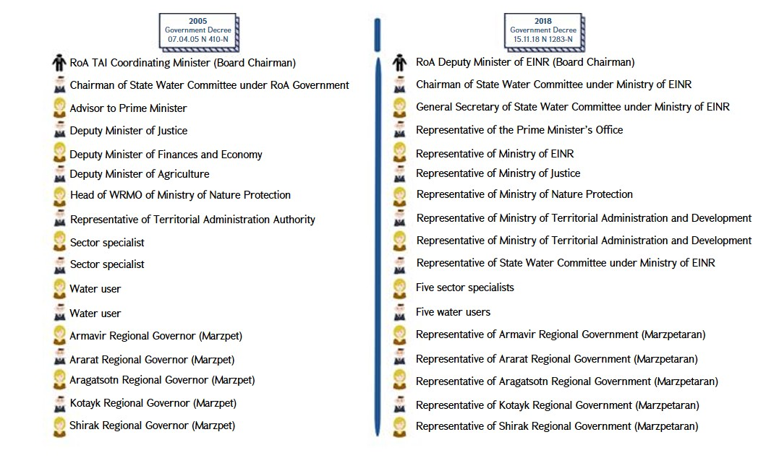
Consequently, the status of comprehensive policy maker of the Board has been transformed into the status of a “department” in the structure of a ministry.
Referring to the requirement of honest and professional expertise of the Board independent from all agencies, with no prejudice towards the honesty and professionalism of the staff employed by the previous structure, in any case, it should be noted that as described above, this function has always been delegated to the Water Committee, however, the latter should have had a much narrower scope of authority and be only a member of the Regulatory Board, rather than being its executive body.
Thus, it is required to review the composition for the Regulatory Board by making amendments and addendums to Annex 2 of the RoA Government Decree No 1678-N of 17 October 2002, to involve all stakeholders at the policy-making level, as shown in Scheme 01.
The status of the Regulatory Board’s Office (Executive Body) is another important issue. Since membership in the Board is a voluntary and unpaid activity, it is essential that the Board receives qualified professional assistance for its activities and have the capacity of presenting a justified position regarding its activities. In this regard, it is essential that the functions of the Executive Board are taken from the Water Committee and transferred to the Regulatory Board for Water Users Associations and Water Users Associations Unions established under the Prime Minister’s Office. This entity should be a centralized body dealing with the development of public policy related to the activities of WUAs and WUA Unions, conducting control, gathering, processing, sharing and disseminating information, and acting as the main driving force of improvements and WUA support. It should maintain an effective communication with the members of the Board, the structures representing them, execute the Board’s decisions and the Chairman’s instructions.

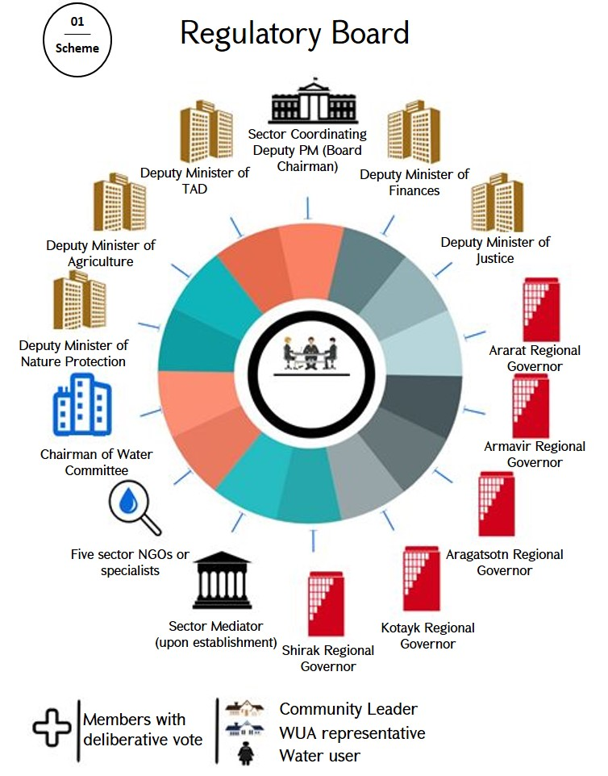

Participatory Management of WUAs
As mentioned in the description of the current situation, although WUAs are entities established and managed by water users, in practice, there are large-scale issues related to participatory management. Currently, in some cases, WUAs include more than 15,000 members. The supreme body of WUA administration is the General Assembly or the equivalent Assembly of Representatives. Since it is objectively impossible to invite general meetings with such a large number of members, all existing WUAs are managed by assemblies of representatives. Therefore, selection procedure of a representative into the assembly of representatives is the most essential cornerstone in the context of WUAs’ participatory management.
The description of current situation already refers to sociological survey data on who the community members trust in addressing water-related issues in their communities. Survey findings reveal a common pattern - the highest level of confidence rests with the subjects selected through direct elections by the population. Moreover, community leaders occupy the first place, followed by the council of elders, community members, WUAs, regional governors, and so on.
In this regard, it is worth mentioning that in most communities, community members note that they have never participated in the elections of representatives, do not remember any event organized on this topic, and are not aware of know who their representative in the Assembly is.
The law does not define any mechanism for selection of representatives, nor provides any mechanism for overseeing the level of representativeness of that election.
Thus, there it is required to regulate the legal aspect of election of representatives. It can be done at closed voting through direct elections, trust signatures, appointment by the council of elders or by delegating the representation to the council members through rotation. Although the latter two mechanisms are also problematic, international best practice and local experience suggests that any interference of local self-governing authorities into the operation of WUAs should be prevented.
However, even with the introduction of such mechanisms and provision of real representativeness of the Assembly of Representatives, there is still an issue related to unpaid positions held in structures created on volunteer basis. The experience of local self-governing authorities indicates that there is low interest among community members in showing proper activeness and participation in unpaid positions in Armenia. In addition, considering that in the course of strengthening anti-corruption efforts, the tendency for claiming such positions with the aim of corruption will also reduce, it is quite predictable that there will be an issue with ensuring proper activeness of representatives. Due to the coverage of their services areas, WUAs sometimes combine 50 and more communities. With no financial guarantees and compensation mechanisms for the costs incurred, it is a burden for a water user representative to pay for getting to the WUA office. Therefore, it is required to develop and implement at least cost recovery mechanisms.
In order to strengthen the representation institution, it is also necessary to regulate the scope of powers of individual representatives apart from the Assembly of Representatives, to define mechanisms for the oversight of WUA activities, meeting invites, processing of water users complaints in their representation zone, recalling of representatives and others.
With representativeness of the Assembly of Representatives in place, there would be no need for an administrative board. Currently, the Administrative Board is a manifestation of re-delegation of the mandate given by water users. The analysis of the scope of powers of the Administrative Board and the review of the current situation shows that part of its powers can be fully exercised by the Assembly of Representatives, while the other part actually rests with the Executive Body; thus, it is simply a subject to legal regulation. Therefore, the Administrative Board becomes “an extra component” for expression and exercise of water users’ will. Along with the legislative changes for introduction of mechanisms to strengthen the Assembly of Representatives, it is required to remove provisions on the Administrative Board from the law, as well.

Dispute Resolution Mechanisms
Combining the facts presented in the description of current situation, it can be concluded that dispute resolution commissions of WUAs are not efficient. Regularly emerging water-related disputes require urgent solutions, however, WUA member water users cannot objectively provide urgent and professional attitude to consideration of the dispute; dispute resolution through judicial proceeding is also ineffective, because the rights breached in this system are usually “delayed rights”, and the process is long and costly. In the end, residents start using “passive boycott” practices, such as not paying water fees, or addressing their complaints to various executive authorities that have no rights to interfere with WUA activities, in most cases. In this regard, it is required to create a professional and effective dispute resolution entity.
The function of dispute resolution can be rested with the institution of mediation for water relations. The scope of water relations is much wider than the relationships between WUAs and irrigation water users. Subjects of water relations include water use for economic, household, livelihood, agricultural, industrial, fish-farming, recreational, energy and other purposes. Therefore, this diversity of interests allows creating a system of professional mediation with financial and legal independence to deal with water-related disputes. This will also have a positive impact on execution of Armenia’s international commitments.
Funding of the institution of mediation shall be proportionately delegated to water using legal entities based on their financial performance.
With a well-developed strategy and legislation, the institution of mediation for water relations will be able to replicate the success story of the Financial System Mediation Institution. On the one hand, it will ensure effective execution of water users’ rights and protection of interests, and on the other hand, remove the burden of inefficient discussions on water disputes from the public administration system.

Publicity and oversight
Description of current oversight of WUA functions shows that the existing oversight mechanisms are not effective. Regarding oversight implemented by Supervision Commissions of WUAs, it should be noted that the latter currently lack internal capacities of efficient control. Consequently, it is required to develop and implement new approaches to oversight of WUA activities.
Usually, oversight activities are based on full access to relevant information. The RoA Law “On Water Users Associations and Water Users Associations Unions” does not define any information access mechanisms other than for provision of information to authorized bodies and access to water users for a certain scope of requested information. Consequently, the first precondition for developing control mechanisms is to define a certain obligation for WUAs to publish full information related to their activities on regular basis. Moreover, this obligation should include not only a limited scope of information on current activities, but also publicity of sessions and meetings of managing bodies, publication of detailed budget and reporting, public disclosure of declarations on property, income and conflict of interests of officials, access to WUA GI systems, etc.
Collection, storage, processing and dissemination of such information will enable water users, representatives, the civil society and public authorities exercising transparent and corruption free supervision. From this perspective, further operation of the Supervision Commission becomes useless, and the related regulations should be removed from the Law by replacing with the obligation of the Executive Body for information disclosure.
To ensure information publicity, WUAs should be provided with websites, GI systems, relevant software and hardware, and professional resources for their maintenance.
The following scheme describes a general model for collecting, storing and disseminating information.
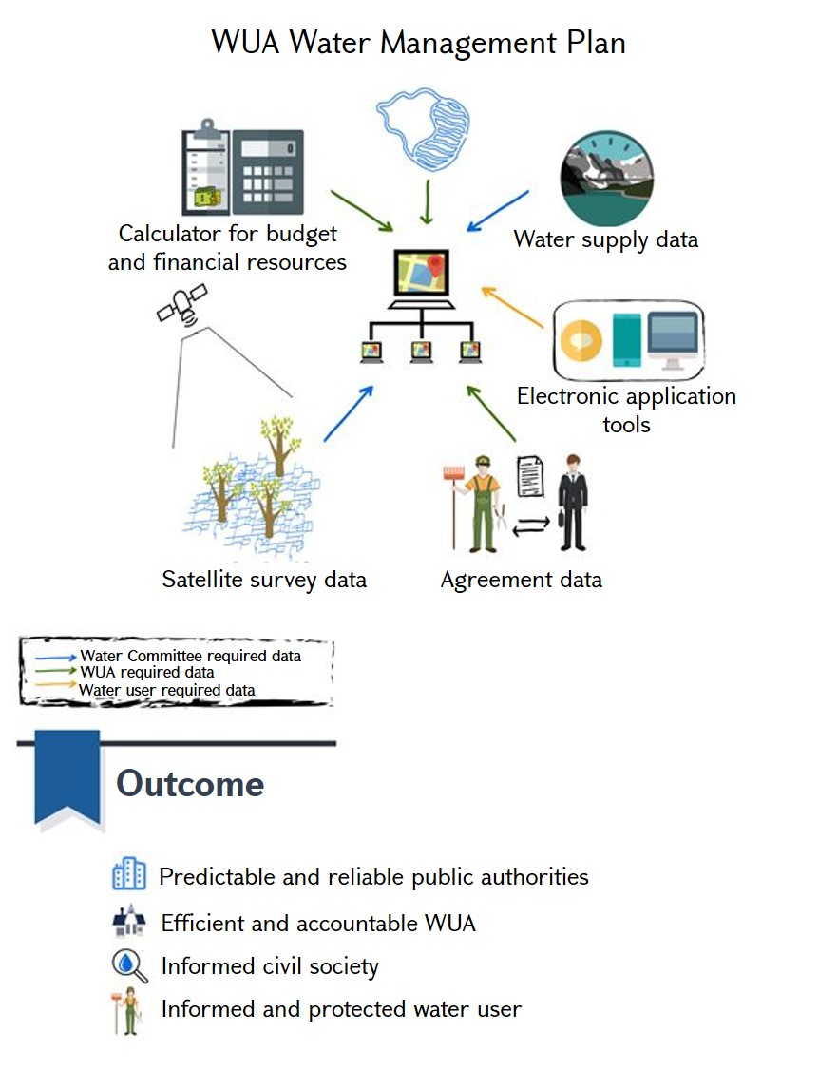
Alongside with the existence of such a system, the importance of state control should not be underestimated. However, any supervisory authority also implies certain impact levers and contains corruption risks. In this regard, it is important that state control exercised in a relatively balanced manner by the Office of the Regulatory Board.
The figure below shows the overall structure of the system as a summary of project activities on improvements of WUA management concepts.
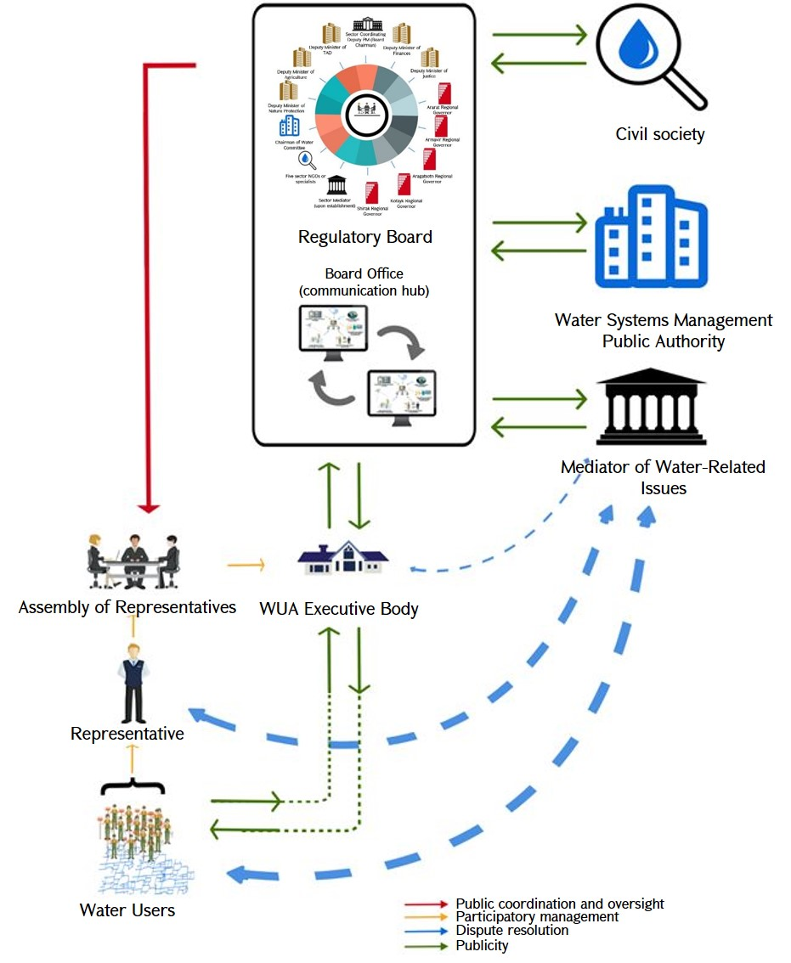
As shown in the diagram, WUA management system has been simplified by removing the Administrative Board, the Dispute Resolution Commission, and the Supervisory Commission. Water users choose a representative of their territory and create an assembly of representatives as the supreme management body. The latter elects the Executive Director, which forms the Executive Body of the WUA and ensures delivery of complete information on the WUA’s activities to the Office of the Regulatory Board. The latter acts as an information exchange buffer. Water users, the WUA, the State Water Systems Management Authority, the civil society, the sector mediator and the Regulatory Board deliver and receive information through that buffer. In the event of a dispute, water users, WUAs or representatives thereof can approach the sector mediator. All system entities can approach the Regulatory Board, which conducts the coordination and state supervision of WUA operations.

Irrigation System Related Administrative Offences and Administrative Proceeding
Based on the description of the current situation, it can be stated that the current inspection system for effective counteractions against administrative offenses in the water sector has a number of gaps, including discrepancy between powers, small staff, gaps in the legal framework required for cooperation with other entities.
In this regard, first of all, it is required to make amendments to the RoA “Code on Administrative Offences” and eliminate legal collisions described in the review of the current situation of this project.
On the other hand, considering international best practices, particularly the French “Water Police” model, we believe that involvement of specially trained police units into the detection and recording of these offenses should be considered alongside with the activities of inspection bodies. Detection of offences can be facilitated by means of adding a provision into the RoA Law “On Water Users Associations and Water Users Associations Unions”, imposing an obligation on water users and WUA officers to report about revealed water-related offenses.
It is also required to revise the rates of fines imposed for administrative offenses, as they are not sufficient to cover the level of danger of the offenses and to dictate an acceptable behaviour.

Financial Stability of WUAs
Long-term financial sustainability of WUAs is possible in case of abrupt reduction of losses through rehabilitation of irrigation network by means of increasing water charges and/or attraction of capital investments and/or WUA involvement into other activities.
The revision policy of water fee can be based on the principle of charging the actual cost of water consumed by water users, at the same time directing current subsidies to installation of water-saving, thus cost-effective irrigation systems. However, such policy could raise some issues for the Government in terms of growing complaints among water users given the low profitability of agricultural business.
There is no visible opportunity of capital investments into rehabilitation of irrigation systems for the Government in the nearest future either.
Therefore, it is required to review the ban of law for WUAs’ engagement in other activities. Particularly, the possibility of granting WUAs the right to import and sell fertilizers, store, recycle, resell and export agricultural products of their service area, as well as engage in other types of economic activity should be considered.

Project Coordination
Coordination of this Project should be conducted in two stages: 1) preparation of regulatory framework required for improvements, and 2) implementation of improvements.
Authorities responsible for implementation of the first stage include the Water Committee of the Ministry of Energy Infrastructures and Natural Resources and the Prime Minister’s Office. The responsibility for implementation of the second stage rests with the Office of the Regulatory Board.
The deadline for completion of the first stage is 1 August 2019.
Activities include:
- Draft amendments and addendums for the RoA Law on “Water Users Associations and Water Users Associations Unions”; assess the need of potential amendments to other legal instruments depending on the approval of the draft.
- Draft amendments and addendums for the RoA “Code on Administrative Offences”.
- Draft government decree on creation of a new Regulatory Board for coordination of activities of Water Users Associations and Water Users Associations Unions.
- Draft charter and financing model for the Office of the new Regulatory Board of Water Users Associations and Water Users Associations Unions.
- Create a Regulatory Board Office for coordination of activities of Water Users Associations and Water Users Associations Unions upon enactment of relevant regulations.
Upon completion of this stage the following outcomes are expected: the above-mentioned drafts have been developed and submitted for the approval of relevant authorities; the Regulatory Board is created and active; the Regulatory Board Office is created and active.
The deadline for completion of the second stage is 1 February 2020.
Activities include:
- Draft Law “On Mediation of Water-Related Issues”.
- Design and implement GIS and other IT infrastructures for a new centralised database used by WUAs.
- Develop and implement reliable mechanisms for transparency of WUA activities and prevention of corruption.
- Conduct awareness campaigns among water users, to inform the latter on their rights and responsibilities in participatory management processes of WUAs, and on control and dispute resolution mechanisms defines by the new law.
- Invite new general meetings at WUAs and ensure that relevant processes for implementation of charter, selection of management bodies and approval of budget are in place in line with the new law.
Upon completion of this stage the following outcomes are expected: Draft Law “On Mediation of Water-Related Issues” has been developed and submitted to the National Assembly for approval; a centralized system of data management accessible to all stakeholders has been introduced in WUAs; corruption prevention mechanisms have been introduced in WUAs; water users are informed about the new WUA management system, are aware of the general framework of their rights and responsibilities and the functions of the entities operating in the system; meetings have been invited in WUAs in line with the new procedures; representatives have been elected; a new charter and budget has been approved; WUAs operate in compliance with the new law. Suggestions for legal amendments are provided in a separate appendix attached to this document.

