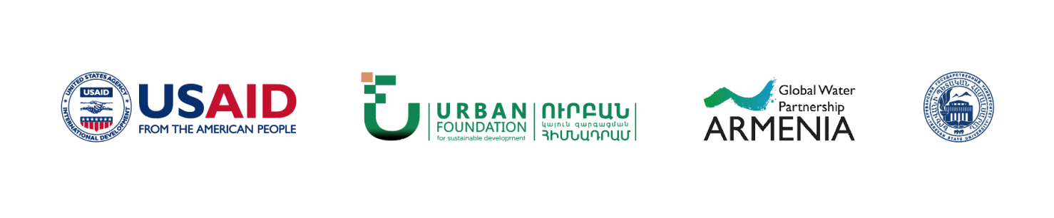

“Participatory and Efficient Use of Water Resources” (PURE-Water) Project

Yerevan, April 2019

Cooperation agreement: AID-111-A-17-00005

Project name: “Participatory and Efficient Use of Water Resources” (PURE-Water) Project
Financed by: United States Agency for International Development (USAID)

Implemented by: “Urban” Foundation for Sustainable Development, “Country Water Partnership” NGO, YSU Environmental Law Research Centre

This paper was made possible by the support of the American people through the United States Agency for International Development (USAID). The contents and opinions expressed herein are the sole responsibility of the authors and do not necessarily reflect the views of USAID or the United States Government.

Appendix 1
Action name | Expected outcome | Implemented by | Co-implemented by | Delivery date | Financial sources | Monitoring criterion
1 | 2 | 3 | 4 | 5 | 6 | 7
Preparation of regulatory framework required for improvements
Draft amendments and addendums for the RoA Law on “Water Users Associations and Water Users Associations Unions”; assess the need of potential amendments to other enactments depending on the approval of the draft. | Draft law on amendments and addendums for the RoA Law on “Water Users Associations and Water Users Associations Unions” is in place; it will be based on international best practices of the sector and justified approaches to problem solutions; it will incorporate safeguards for WUAs’ transparency, accountability and participatory management; it will define principles for relationships with public and other authorities and safeguards for independency; it will provide reliable mechanisms for efficient protection of water users’ interests and for reaction of WUAs to current issues of the system. | Water Committee of the Ministry of Energy Infrastructures and Natural Resources |  | 13 May 2019 | Not required | Draft law on amendments and addendums for the RoA Law on “Water Users Associations and Water Users Associations Unions” has been completed in line with the expected outcome and is currently in place.
Draft amendments and addendums for the RoA “Code on Administrative Offences”. | Draft law on amendments and addendums for the RoA “Code on Administrative Offences” shall define liability mechanisms for water users and WUAs for offences of water use in irrigation; the mechanisms shall define administrative liabilities both for illegal water use and awareness but ignorance of such activity. | Water Committee of the Ministry of Energy Infrastructures and Natural Resources |  | 13 May 2019 | Not required | Draft law on amendments and addendums for the RoA “Code on Administrative Offences” has been completed in line with the expected outcome and is currently in place.
Draft government decree on creation of a new Regulatory Board for coordination of activities of Water Users Associations and Water Users Associations Unions. | Draft government decree on creation of a new board for coordination of activities of Water Users Associations and Water Users Associations Unions is in place; it includes all interested public authorities and is managed by the Deputy Prime Minister of the sector. | Office of the Prime Minister |  | 13 May 2019 | Not required | Draft government decree on creation of a new Regulatory Board for coordination of activities of Water Users Associations and Water Users Associations Unions has been completed in line with the expected outcome and is currently ready for implementation.
Draft charter and financing model for the Office of the new Regulatory Board of Water Users Associations and Water Users Associations Unions. | Charter and financing model for the Office of the new Regulatory Board of Water Users Associations and Water Users Associations Unions is in place. | Office of the Prime Minister |  | 31 May 2019 | Not required | Charter and financing model for the Office of the new Regulatory Board of Water Users Associations and Water Users Associations Unions is completed in line with the expected outcome and is ready for implementation.
Draft law on “Water Relations Ombudsman”. | Draft law on “Water Relations Ombudsman” is in place; it provides comprehensive safeguards for legal and financial independence. | Office of the Regulatory Board | Ministry of Nature Protection, Ministry of Justice, Office of the Prime Minister | 31 January 2020 | Not required | Draft law on “Water Relations Ombudsman” is completed in line with the expected outcome and is ready for implementation.
Implementation of improvements
Creation of a new Regulatory Board for coordination of activities of Water Users Associations and Water Users Associations Unions upon enactment of relevant regulations. | Creation of new Regulatory Board Office for coordination of activities of Water Users Associations and Water Users Associations Unions and recruitment of experienced and respected specialists of the sector on competitive basis. | Office of the Prime Minister |  | 1 August 2019 | State budget, other sources allowed by law | The Office of the Regulatory Board of Water Users Associations and Water Users Associations Unions is currently active.
Design and implementation of GIS and other IT infrastructures for a new centralised database used by WUAs. | Design and implement GI systems for collection, treatment, analysis and distribution of data required for WUA activities, including information on water intake, driftage, irrigation water supply applications, irrigation water supply quantity, land size, crops, standard indicators, water user charges, accounts receivable per water user; ensure software and hardware, and professional resources required for the support of those systems. Implement other infrastructures required for collection, storage, treatment and distribution of information. | Office of the Regulatory Board |  | 1 January 2020 | State budget, other sources allowed by law | A centralized GIS and other required infrastructures have been implemented into operation at WUAs in line with the expected outcome.
Develop and implement mechanisms for prevention of corruption and transparency of activities at WUAs. | Develop procedures for prevention of corruption, including declaration of property and income of WUA management bodies, as well as conflict of interests; ensure that all information on WUA operations, including GIS data, are accessible through WUA websites. | Office of the Regulatory Board |  | 1 January 2020 | State budget, other sources allowed by law | WUAs have official websites, providing access to information on declaration of property and income of WUA management bodies, conflict of interests, as well as all information on WUA operations, including GIS data.
Conduct awareness campaigns among water users, to inform the latter on their rights and responsibilities in participatory management processes of WUAs, and on control and dispute resolution mechanisms defines by the new law. | Develop and implement awareness campaigns in cooperation with mass media, local self-governing authorities, sector NGOs, WUAs, Armenian National Agrarian University, successful farmers, to increase the awareness of water users on participatory management of WUAs. | Office of the Regulatory Board |  | 1 February 2020 | State budget, other sources allowed by law | Short informative videos, were broadcast on mass media, including television, lectures and seminars were conducted in communities, awareness posters were posted in communities, one-off classes were held in high schools of rural communities, lectures on participatory management of the system were delivered to students of relevant faculties in the Armenian National Agrarian University.
Invite new general meetings at WUAs and ensure that relevant processes for implementation of charter, selection of management bodies and approval of budget are in place in line with the new law. | Invite new general meetings at WUAs. Adopt a charter complying with the new law, organize selection of management bodies and approve the budget. | Office of the Regulatory Board |  | 1 February 2020 | State budget, other sources allowed by law | WUAs have adopted a new charter, have selected new management bodies through participatory, transparent and democratic elections, have approved the budget and are currently active.

